BILL OF MATERIALS
Product: PENNINGTON 7 LB POUCH
Pouch Specifications:
- Pouch is black with a flower scene on front
- Dimensions of pouch are: L 13” x W 10.25” x 4” GUSSET
- Pouch fitted with gusseted bottom and zipper top
Pouch Machine Recipe:
- Select program titled (7LB) on Leepack machine
- Use program #7 on the scales
- Set speed at 22 per minute
Case Specification:
- Case is brown corrugated with black print
- Case inside dimensions are: 13-1/4”W x 8-7/16”D x 15-1/2”L
Packing Specification:
- 6 ct. pouches / case , packed horizontally into case
- Date code to be applied both to pouch and case
- No outside label required on case
- The four digit date code represents the date of packaging (i.e. 02-09-2009 = 0409 which means the 40th day of the year 2009
- The { EXP } means expiration which is three years ( i.e. EXP 0212 ) The 0212 means the second month of the year 2009
- 45 cases/pallet double stretch wrapped with outside pouch indicator. Every other pallet to have top slip sheet.
- Numeric order of production (i.e.1,2,3,4) and date of manufacture to be written outside stretch wrap
- Pallets may not be double stacked in warehouse
Pallet Configuration:
- 9 cases per layer, column stacked 5 high=45 cases per pallet
SHIPPING INFORMATION:
- Pennington pallets require a bar coded sticker on all four sides of pallet stickers with the BOL.

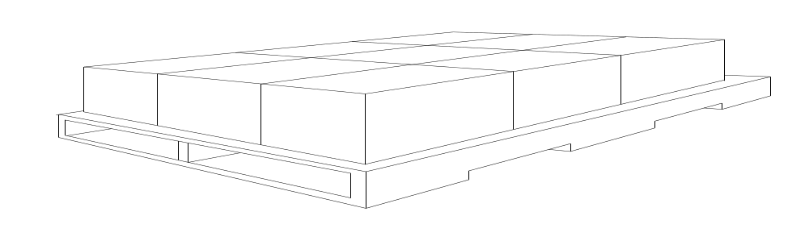
Rev: 00
Date: 03/30/2011

